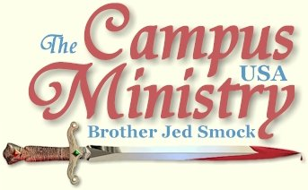
BROJED.ORG
brojed@aol.com
Cell 573-999-0347
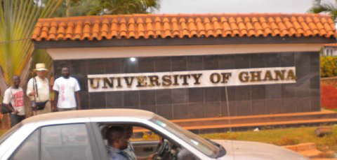
University of Ghana
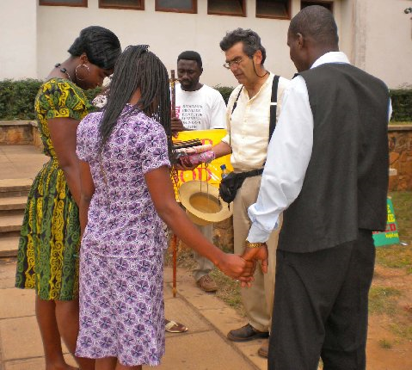
Prayer with University Students

Back in My Element
August 19, 2009, this morning, I was awakened at 5 by an amplified message coming forth from the wake down the street. The sermon went on for an hour, so that I never got back to sleep. Instead, I arose to exercise. We experienced our first miracle in Ghana: someone actually arrived at the appointed time. The Pastor picked us up at 8 to take us to his home for breakfast. However, we still did not make it to the church until after 10. Then everyone socialized for 20 minutes. I finally said to Pasha, ”Don’t you think that we ought to start the meeting?”
At the request of Brother Francis I spoke for the first time from one of my outlines, “Every member Evangelism.” I had gathered some quotes from Roy J. Fish and J. E. Conant: “The great commission is sufficient authority, but it is not sufficient motive. It not the imperative of an external command that sends us after the lost; it is the impulse of His indwelling presence… Go does not mean send… The only cure for church trouble is love, and love takes control the moment a church surrenders to the work of soul-winning and starts out seeking the lost.”
I spoke of the call of the prophet, “Whom shall we send, who shall go for us?” Isaiah responded, “Here I am send me.” We need volunteers in the army of God. God is calling. Who will respond? All the members of my class responded. I laid hands upon them all.
Next we had the graduation ceremony, which I hoped would be the conclusion of the service. I was anxious to do the final workshop portion of the school since we were going to the University for the first time. When I first agreed to come to Ghana my understanding was that the universities would be in session. Later I was informed that the universities would be on holiday during my visit. Yesterday, I found out that Kwame Nkrumah University of Science and Technology was opened. Therefore, I insisted that we take our evangelism school there. However, after we gave out the certificates, the pastors had to have their final words and render the proper credits to everyone involved in the seminar planning and administration. This went on and on. I was reminded of the credits at the end of a Hollywood movie, which might go on for 10 minutes. In a movie virtually no one stays for the credits. On the other hand I usually do if I like the movie. I rarely go to a movie that I do not like since I usually read reviews before I go so that I will know whether I am likely to be interested or not. Well, the pastors went on and on expressing their appreciation of all involved including me and Charlotte and my wife and supporters back home. (that's you!)
Africans are a very gracious people; but when I am ready to go forth and preach, I do not like to be delayed. Finally, the credits ended and we piled in the Hummer to head for campus. The loud speakers were mounted on top of the cab and the brothers preached as we drove through the city. The pastors were wise to turn off the amplification just before we got to campus. However, the guards at the gate of the University were fearful when they saw the amplifiers. Consequently, there was very animated conversation between the guard and the pastors but the pastors finally convinced the guard that we would not be using the amplification. I was quite relived as the gate was opened for our entrance.
The campus was large and the grounds were relatively well maintained for Africa. We passed numerous houses where evidently the professors live. We drove to the center of campus and outside of Unity Hall we saw perhaps a hundred students sitting around and socializing. We walked up to a group of about 20 and Francis introduced me. When I introduced Charlotte, several of the boys said, “Wow.”
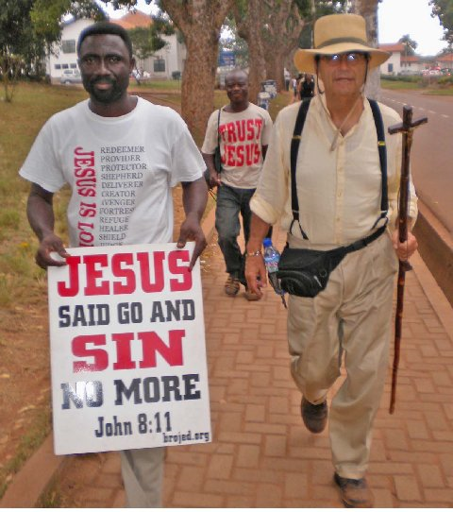
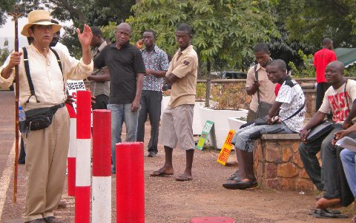

I spoke of my purpose in coming to Ghana. I taught on John 14:6, delivered a basic salvation message warning them of specific sins which would damn their souls. I gave a condensed version of my testimony. Then I asked if there were any questions. There was no response. Next, I asked how many of them were following Jesus; most of them raised their hands. I asked the few that did not raise their hands why they were not Christians. Then they claimed they were. Finally, I pleaded, “Talk to me. I am here to dialogue with students from Ghana.” Eventually, one student did ask a question. That opened up some of the rest of them. There were a few who asked questions about Hell. One asked, how I convinced people that there was a Hell.
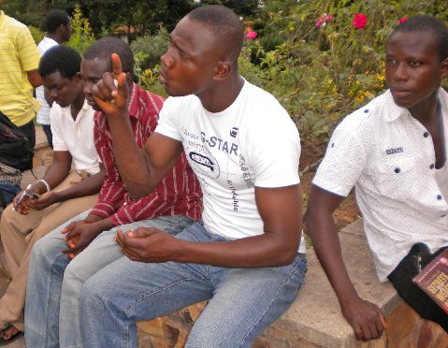
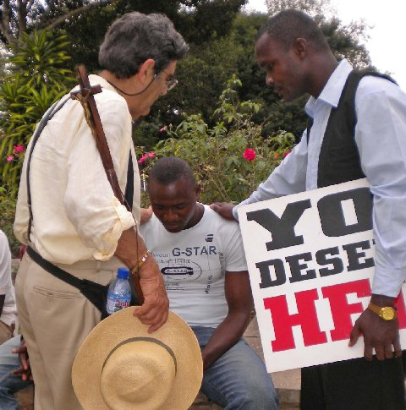

Another asked about the call of God and how one could know that he had been called and to what office. When a question on Hell came up the third time, Brother Francis evidently discerned that at least one of them had been influenced by the Jehovah Witnesses so he interrupted and spoke against that heresy. I decided that it would be a good time to let Francis take over so that he could get the experience since he had never spoken on a campus before. Francis did well in fielding their questions. One young man dominated the questions asking about baptism, purgatory, Papal succession, and finally the end times. The end times are Francis’ forte since he teaches that series for Faith Tech Bible Schools in Ghana. Now and then Francis and the other pastors asked for my input to a question. Meanwhile, others from our school of evangelism witnessed to individuals and small groups of students.
Peter talked with me, he discerned that although the students virtually all confesseed to believing in Jesus, he suspected that few of them were born again. He believed that they had the outward forms of religion; but they lacked an inner experience of God. I agreed.
We left campus about 3:45. Both Charlotte and I were exhausted. But I was very happy that we had the opportunity to preach on campus even though only freshman were on campus for orientation. Evidently, the upper classman have not yet arrived.
We returned to a pleasant dinner at Pastor Asaymoah’s home, but we were too exhausted to linger after dinner. Pastor returned us to the hotel and I took a nap. Later he picked us up to go to the internet station. However, we no sooner got on the internet then there was a blackout for thirty minutes. Once we got back on line the computers are so slow that we only got about 30 minute of our allotted time to read mail and to make a few brief posts.
Pastor said that his wife was getting on his case that the white man would think that they are inhospitable; since you take him back to your hotel right after dinner. He tried to explain to her that the white man is tired. I will write a note to the Mrs. assuring her that we considered them highly hospitable; but that we needed our rest to remain strong to minister. Pastor has a nice home, the food has been very good and he has a close and fine family.
Preaching on the Bus
August 20, 2009, we anticipated that with no seminars or workshop scheduled that today would be relaxing with a visit to the Cultural Center in Kumasi and a return trip to Accra. It turned out to be our most uncomfortable day.
We were able to say goodbye to Mrs. Asaymoah as she was leaving for her auto mechanic shop. We apologized for being too tired to take advantage of her gracious hospitality. She seemed to understand. After breakfast the gang headed for the Cultural Center, which turned out to be a place of arts and crafts. For Cindy and the girls, I bought necklaces, a bracelet, a fan, and leather purse. I purchased a sheaved knife for myself.
Then we left for the bus station. It appeared that the bus would be nice enough we had the front seat and it was supposed to be air conditioned. We sat in the bus for about an hour. Evidently, the bus does not leave at a scheduled time but leaves when it is full.
Finally, when we left the station Brother Francis stood up and prayed for our safety. Then he started preaching walking up and down the aisle exhorting on righteousness, temperance and judgment. He preached against what he calls “the condom gospel.” The condom is a rubber that the professing believer wears over his body; but he lacks salvation in his heart. The condom protects him from true religion. It was a very strong sermon, which lasted about 20 minutes. I suppose in the US he would have been kicked off the bus. But everyone took the sermon in stride. He prayed healing prayers over a couple of ladies. Afterwards, I asked if he had ever preached on a bus before. He answered, “I used to but then I stopped; but the spirit of evangelism within me has been rekindled.”
Well, it turned out the air conditioning was not working and the windows could not be opened. A lady behind us had malaria. The driver thought nothing of passing on solid double lines. Much of the road was unpaved. On the last portion the road was under construction and cars were coming from every which way. This was the worse 6 hour drive which I have ever been on. It was Charlotte’s first bus ride ever. She says, “And hopefully her last.” When we finally arrived in Accra, we had to cross the road on foot which involved climbing barriers. However, we were glad to be out of the bus and back into cool air. Our driver met us in the Mercedes on the other side of the road. We then had another hour drive back to the hotel.
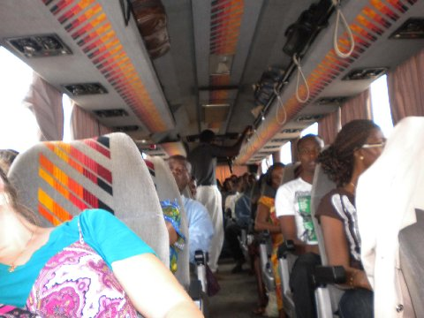
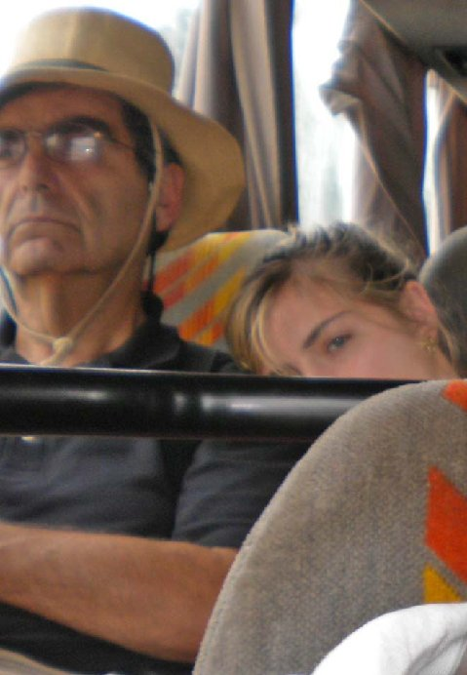
The Long Bus Ride

Francis, Peter and Simon were good humored through it all and Charlotte and I tried to be. They are always ready to help and ease any discomfort in any way that they are able.
At the end of the day Brother Francis said that tomorrow would be a day of rest. I quickly nixed that idea. I have too much invested in this trip to take a day of rest. I will rest on the plane. I insisted that we go to the University of Ghana to preach tomorrow. I wanted to at least scout out the campus for a possible future visit to Ghana. I needed to know the terrain. Brother Francis agreed. He suggested that we go in the afternoon. I also nixed that. I wanted to get there by noon.
Shutting Up the Hooters at the University of Ghana
August 21, 2009, we took a taxi to the University of Ghana and arrived around noon. We walked past many academic buildings and finally stopped in front of the library. Brother Francis introduced me to three young ladies who were walking to the library. I briefly gave them a gospel message, related my testimony and spoke of my mission to Africa. They were very attentive. I noticed brightness about their countenance which convinced me that they were truly saved. I prayed with them.
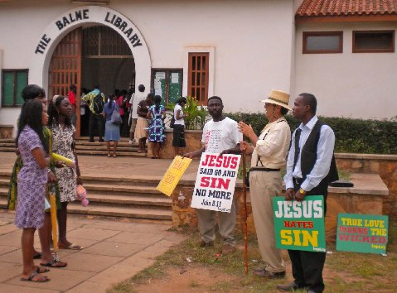
Next we walked to Commonwealth Hall which sat upon the top of a hill where many students were standing around. Francis went inside to get permission to speak to the students. The authority agreed to let us speak; but it would have to be confirmed by the student body president who was standing outside. The student president granted his permission. I preached to four different groups covering basic themes of salvation and Christ’s mission and our mission. I told them that true religion must come from the heart and be reflected by a life of obedience to the Lord. Each time I really worked on encouraging the students to ask me questions or talk to me. It was difficult but each time; but I would finally get some polite questions and then requests for prayer. My messages were strong; but not as strong as I would preach in the US since I am a guest in their country and I do not know them like I know American students. This is the same response I received when preaching at universities in the Philippians. I was somewhat frustrated because I thought that many of the students outwardly were confessing the faith; but were not truly born of the spirit. The pastors sensed the same thing. I am not used to speaking to a crowd where everyone claims to be Christian and many of them may well be living morally upright lives. Nevertheless, I was happy to preach and I am convinced that with more experience ministering among them that I will learn how to prick their hearts (penetrate their consciences). As I was leaving one young man asked me to pray for him. He aspired to be an evangelist like Billy Ghaham.
We toured the bookstore, which was not up to par compared to an American University of this size. Some of the books were old and somewhat dog eared. Next we went to the internet café which is in the first floor of one of the men’s dorms. As I checked my email, I heard a commotion outside. Francis came in and announced that he had been preaching to the students. I quickly finished up my email session and went outside to join Francis.
Francis had heard the males from the dorm balconies “hooting” (cat-calling) the girls as they were passing. He pulled out his “Jesus Hates Sin” placard and rebuked the boys for their lustful hearts. Suddenly, a hush fell over the boys from the balconies. Then someone asked, “What is sin?”
Francis replied, “Knowing to do good and doing it not.”
Next Francis held up his “God Loves Righteousness” sign. Someone asked, “What is righteousness?”
Francis answered, “Doing the right thing. Good behavior.”
Francis lifted his sign which read, “Jesus said, Go and sin no more.” Francis preached holiness.
Finally Francis raised his sign which read, “You Deserve Hell.” “You are judging us,” students objected.
Several of the males from the balcony cried, “Go away, we do not want to hear you.”
Shortly afterwards, I came out to get into the action and preached. The students were more courteous towards me. I suspected that it was since I was an American. Someone from the dorm came out and handed me a bull horn. Meanwhile, Peter and Simon who had gone to another part of campus returned because they had heard the commotion. Peter translated for me. Eventually, I gave a call for anyone who would repent and confess to sin to come down and I would pray with them. One fellow responded and acknowledged that he was a backslider. We prayed with him that he would be restored to fellowship with the Lord.
I had told Charlotte who had stayed at the hotel today that I would be back by 4PM; so we left rejoicing. Francis said it was his best day of evangelism during the time I was in Ghana. Francis succeeded in exposing the condom gospel with which they had been covering their sinful hearts. It affirmed to me that at heart students are pretty much the same everywhere. Some just put on a better outward show of religiosity than others.
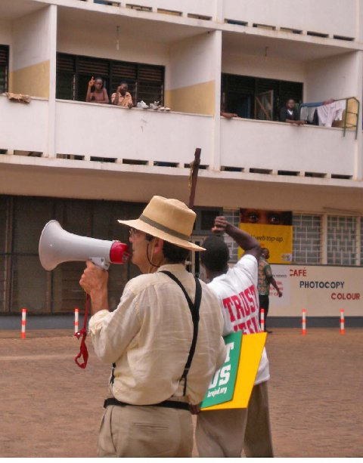
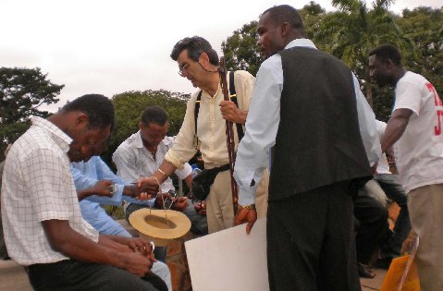
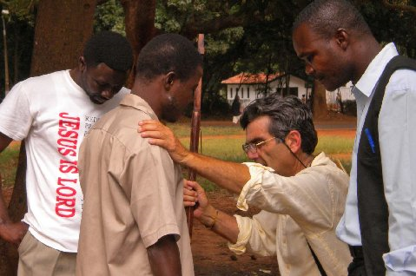

At dusk Francis took us on about a 15 minute walk to his home which is away from the busy streets in an area which is being developed. His home reminded me of a homestead where many Americans got their start to eventually prosperity. He had his acre of land and concrete house for which the Lord has given him a beautiful vision which I am confident will come to pass. Presently, there is no electricity going to their home. But that will come. More importantly the power of God is there. We enjoyed seeing his home. Chickens and ducks roam his land. He has a nice vegetable garden. He has a wonderful life with three children. His two boys are named Peter (after Peter Smith) and Finney after Charles Grandison, the two men of God who have influenced him most.
Peter had a party planned for us tomorrow. However, that is not possible because our flight home leaves at 10 AM. Francis thought that it left at 10 PM. So we will say our goodbyes in the morning. I am confident the whole gang will be there to see us off. We have had good fellowship with the brethren. although both Charlotte and I are looking forward to returning to the good old USA.
Reflections
Over the years I have received numerous invitations to come to Africa which I have ignored. However, when Brother Francis invited me, I took note. I was prepared for his invitation because months before Peter Smith, president of Two Witness Ministries, had shared some correspondence in which Francis said he was considering asking me. Peter in conjugation with Faith Tech Ministries has been doing missionary work and establishing Bible schools in Africa for decades. Also I had read an internet article about an African street preacher which had interested me in taking the gospel to the universities and streets of Africa. Therefore, when Francis issued his invitation I was opened. Peter Smith highly recommended Francis as one of his sons in the faith.
I put somewhat of a fleece before the Lord. I decided to invite Charlotte since she has been in Florida for schooling we had had little fellowship. I thought this would be a wonderful way of bonding with her and give her an opportunity to get a feel for medical mission for which she has often expressed an interest. When she excitedly agreed to go, I considered it the affirmation of the Lord to go.
Shortly after I told Brother Francis and Peter that I would go, I became apprehensive. At my age, I became concerned about the health issues, malaria, yellow fever, dysentery, etc. I had not fared well in missionary trips to Haiti and the Philippians and I did not want to go through some of the common health challenges of Third World travel. I had heard of missionaries whose health had been destroyed in Africa. I even became worried that the plane would crash. But I had given my word to Francis, Peter and Charlotte; and so I saw no way out. Like Ester, my attitude was, “if I perish, I perish.” I was actually thinking that Africa could be my last stand. All of weakening my joy and faith.
In May, I expressed my concerns in an email to Peter Smith to which he replied, “Jed your health fears are unfounded, they are coming as suggestions from the father of lies to distract you from you mission. Our great God and protector will watch over his Word to perform it, and will watch over His servant to strengthen him for the task set before him. I know so much is unknown to you at this time, but God will be there with you just as He is everywhere you preach and teach, you are going forth by faith just as you always do, and these fears can be turned to your advantage if they will 1. motivate you to spend more time in prayer, and 2 motivate you to generate broad prayer support for this trip. Because you can do such harm to the kingdom of the enemy, do not be surprised at the spiritual attacks that may come your way.”
Peter and Doris assured me that prayer for my mission would have priority in their intercessions. I considered Peter’s words to be from the Lord and as a result this spirit of fear left me. I did make sure to build up my prayer support; and I credit these prayers from keeping this spirit from attacking me again. After all, “God has not given us a spirit of fear, but of love, power and a sound mind (1 Tim 1).”
As it turned out most of my apprehension was unfounded. I did not encounter one mosquito and we were loaded with insect repellent. Unfortunately, in the last few days Charlotte did have several large mosquito bites which made her uncomfortable. The food of Ghana was not only was tasty; but it agreed with my digestion system better than my diet in America. I followed the travel doctor’s orders by taking my malaria pills and staying away from salads and was cautious of where we ate. I am wondering if it was not all the rice that agrees with me. Our rooms were comfortable and the facilities modern and clean. We were not overwhelmed with the heat; but then we were in Ghana at the coolest time of year, mostly the low 80’s. I had been concerned about getting the required yellow fever shot before my correspondence with Peter, but as he predicted I had no adverse reaction to it. Understand that I am not much of a doctor or medication type person.
Before this trip, I did not have much a vision to personally go to the foreign field. After all, most of the nations of the world are represented on America’s campuses. All over Africa they send their best and brightest to study in the U.S. I can reach into other continents without going abroad through preaching on campus. As a result of this trip, I see the importance of going overseas to proclaim the gospel.
Brother Francis informd me that we gave out 200 of the 500 certificates which I had prepared for the schools. [He had me sign the rest of the certificates and he is going to teach the course in confrontational evangelism from my outlines and the notes which he took during my lectures. They don’t like for things to go to waste in Africa]. The attendance outside of Accra was not as high as Francis anticipated. Although only about 25 showed up daily to the seminar in Kumasi , the eagerness to learn from these students still made it a very worthwhile time.
Another thing Peter Smith wrote me in May which turned out to be prophetic was, “Once you arrive in Ghana and you and Francis meet and greet each other, and the adventure begins you have the opportunity to learn the culture, and build relationships with the people, and then perfect love will quickly dispel all fears, and you will see that God has you over there for HIS own purposes.” We are confident God had his purposes in sending us to Africa, some of which are obvious and of which we already have seen fruit in highly motivated men preaching in the open air and the many souls which made professions of faith.
Charlotte and I loved everyone we met and they were very loving and gracious towards us. I am not used to being treated with such respect. I was God’s man for the hour. Usually when I go to a college town I am not greeted by a smiling pastor who has everything planned to make me as comfortable as possible in the circumstances. When I do have the support of a local church, few can match the Africans for the love, respect and honor they bestow upon “the man of God.” If the pastors could do it for me, it was done.
Charlotte and I built relationships which may prove to be even more productive in the future. I now have a greater vision for foreign missions and want to make it more of a factor in my ministry in the future as the Lord provides the money. I am convinced that open-air preaching is the key to bringing revival at home and abroad.
Charlotte is already talking of returning to Africa with nursing friends to do medical missions. Cindy and Charlotte have been spoken of a mission trip to Haiti. Cindy did mission work in Haiti before we were married and still maintains the contacts which she made over 25 years ago. All my new contacts in Ghana want me to return which is evidence that they were pleased with the results and thought that we made a difference. A brother from Tanzania has been pleading with me to come. Ah, the Macedonian call can become very loud and echoes from many places when one is listening.
My time with Charlotte was precious. We had some long end of the day talks, including memories of her childhood. Charlotte took her first missionary trip alone with me when she was three years old. Interestedly, it was to the farm of Peter Smith, who had invited me to northern Michigan for an evangelistic crusade. This last trip to Ghana was under the authority of his Two Witness African mission.
Charlotte was a real trooper. This was her first experience in third world missions. I had been to Haiti and the Philippians so the cultural shock must have been greater for her than me. But she handled it very well and with good humor. She kept up a very fast pace in a man’s world without complaints. She was my Barnabas, always being an encouragement. Charlotte did the photography and helped me keep track of my things. On a few occasions in my teaching (usually as a result of working with a translator) I would lose my train of thought. Charlotte would get me back on track. Charlotte was a good communicator with the people. Travelling in a foreign land is always a challenge. She did better on picking up on the different accents of the Africans than I did, which helped keep the lines of communication open. Charlotte carried much of the load of the social interaction, which enabled me to rest in my thoughts after all the demands of ministry. Charlotte and I built good memories which we will be able to reflect upon for the rest of our lives.
Peter Smith and Bob Reid, founder of Faith Tech schools, have wonderful fruit from their ministry. They laid the foundation for the success of my mission. I know of no ministries which has been more effective than Two Witnesses and Faith Tech in getting the moral government message to the foreign field. I met a number of people in Ghana that had studied from Faith Tech who are now solidly moral government men, including Francis, Peter and Simon. A significant number of my students in the school of evangelism graduated from Faith Tech Schools. Even the internationally known physician, Rev. Dr. Anane-Frempong Asafo-Agyei, is a graduate of Faith Tech. He told me that he arrived fifteen minutes early for each teaching session, which is remarkable evidence for an African of his commitment. In Ghana we not only raised up many who are committed in taking Christ to the streets and campuses, but we raised up men who have a sound doctrinal education.
Short term missionaries are become more and more a part of the ministry of missions. It seems like those who go to the foreign country and live are rarer with the passage of the years. I have a great respect for those who still make that commitment. If you will pardon my baseball analogy, the short term missionary has become like the set up man or the closer in baseball. When I was a boy the starting pitcher was expected to finish a game, go all nine innings. Today, a picture has a quality start if he can last six innings. Then the relief corps finishes the game. Baseball has changed; missions have changed. Fewer go to the foreign country and stay for the long haul. Hopefully, the permanent missionary will always be with us. But the short time missionary is playing a greater and greater role in the area of missions; he has become a vital part of the mission field. Faith Tech and Two Witness Ministries are star players in this specialty. I am but a rookie in this field.
On the flight over I watch the movie, 61*, which tells of Mantle and Maris’ pursuit of Babe Ruth’s record of 60 home runs. Maris broke the Babe’s record; but he did it with an asterisk after his name stating in that he played in the era when the baseball season was extended from 154 to 162 games. Later the steroid boys broke Maris’ record. All of them always had the ghost of the Babe to whom every great ball player is compared. Modern day missionaries especially short term ones have as asterisk after our name. Air travel and email and other conveniences of modern life have made the missionary’s task less formidable. David Livingstone (1813-1873) is the pioneer of missions in the African deep; he disappeared for years until Stanley found Livingston, who later died in Africa. No one will ever surpass his achievement and reputation. Livingston once said, “I never made a sacrifice. We ought not to talk of sacrifice when we remember the great sacrifice that he made who left his Father’s throne on high to give himself for us.”
And with Livingston’s quote I will, for now, close my African journal until the Lord sees fit for me to take it up again. Thank you once again to all who gave your financial support or interceded in prayer to make my mission to Ghana possible and successful. My students assured me that they will continue the work of open air evangelism and confront the forces of darkness. I am confident that the spirit of evangelism has been rekindled in Ghana. Many, even beyond the ones I personally ignited, will catch the fire to go out into the streets, highways and hedges to compel men to come into the Kingdom of God.
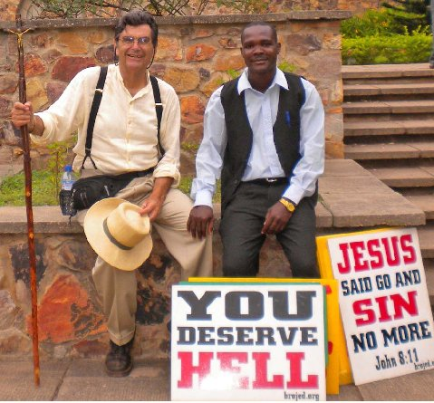
You may donate to CMUSA by through Pay pal by going to our website: Brojed.org
or by mailing a check to CMUSA, 2402 Longview Dr. Columbia, MO 65203

